Implementation Plan - Next-Generation Financial APIs Platform (Payments MVP)

Problem Statement: Design and plan the startup of a next-generation financial APIs platform for the Payments domain, aligned with
- an enterprise architecture framework (TOGAF),
- BIAN domains,
- Domain-Driven Design (DDD),
- BIAN Semantic APIs,
- ISO 20022 messaging,
- an API-first approach,
- event-driven architecture (EDA),
- and AWS deployment.
The outcome is a production-grade MVP for a controlled environment covering a demoable end-to-end payment flow, with architecture artifacts and infrastructure as code.

Requirements (gathered):

Scope: production MVP, controlled environment.
Domain: Payments.
BIAN Service Domains:
Payment Initiation → Payment Order → Payment Execution.
Hybrid stack: ASP.NET Core (.NET 8) for core domain services + Python 3.12 / FastAPI for data, events, and integration.
Processing: mock rail by default + adapter ready for external sandbox.
EDA: Amazon MSK (Kafka) for domain events + EventBridge for integration/routing.
Security: Base - OAuth2/OIDC (Cognito), TLS, API Gateway with throttling.
Data: Event Sourcing + CQRS + Saga for the payment lifecycle.
Success: demoable end-to-end flow + architecture artifacts (OpenAPI, C4/EDA, BIAN↔ISO 20022 mapping) + AWS deployment baseline (Terraform) and CI/CD.
IaC: Terraform. ISO 20022 modeling with custom DTOs (pain.001, pacs.008, pacs.002).
Coding standards: Python with 4-space indentation, docstrings, type hints, f-strings, functions under 30 lines.

Background (research and design decisions):

BIAN ↔ ISO 20022 mapping (flow reference):

- Payment Initiation (channel) receives the customer's payment intent → produces/validates pain.001 (CustomerCreditTransferInitiation).

- Payment Order manages the payment order (order fulfillment), validates, applies rules, and orchestrates the Saga → translates to pacs.008 (FIToFICustomerCreditTransfer).

- Payment Execution executes against the rail (mock/sandbox) and emits the status → pacs.002 (FIToFIPaymentStatusReport).

Architectural style:

API-first: OpenAPI 3.1 contracts are defined before code and act as the source of truth. Resources and verbs follow BIAN Service Domain semantics (Behavior Qualifiers, Control Records).
DDD: each BIAN Service Domain is a bounded context with its own model, aggregates, and ubiquitous language.
Event Sourcing + CQRS: the PaymentOrder aggregate persists events (not state); a projection builds the read model (query side). A Saga (choreographed/orchestrated) coordinates Initiation → Order → Execution.
Hybrid EDA: domain events in MSK/Kafka (event store/stream); EventBridge for routing to integrations and cross-domain rules.

Technology:

- .NET 8 for PaymentOrder and PaymentExecution (core domain, ES+CQRS).
- Python 3.12 / FastAPI for Payment Initiation (channel/BFF), rail adapters (mock/sandbox), and data/projection components.
- Terraform for landing zone, network, MSK, EventBridge, API Gateway, Cognito, DynamoDB/Postgres, ECS/EKS or Lambda.
- ISO 20022 modeled with custom validated DTOs (no official XSDs), serializable to JSON internally and XML at the edges.

Context view (C4 - container level, simplified):

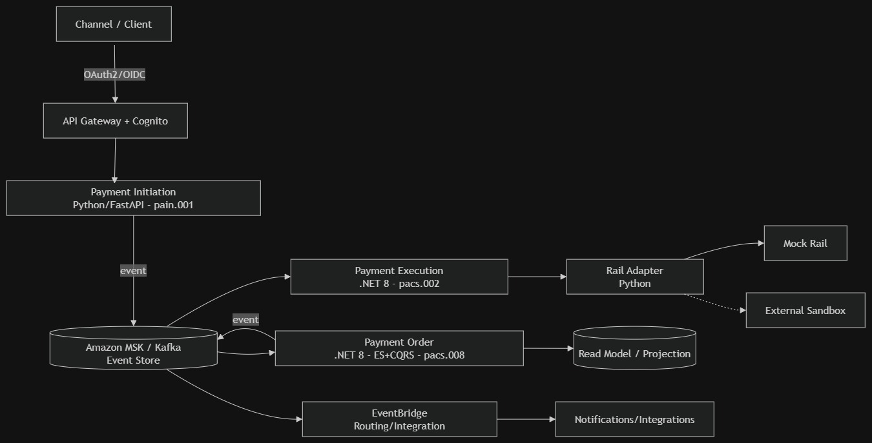

Payment Order (Saga)

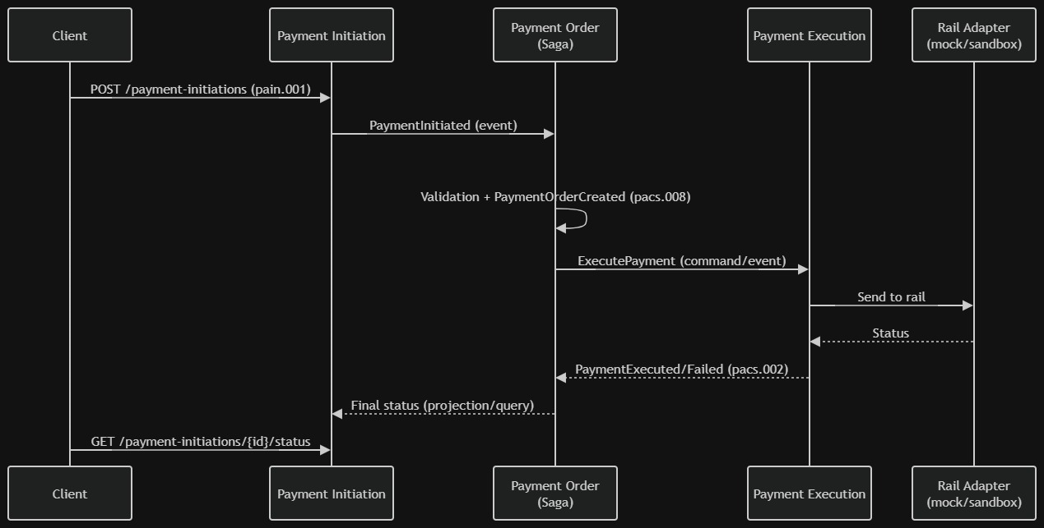

Proposed Solution (summary): Build a monorepo with contracts-first OpenAPI, three bounded contexts (Initiation in Python, Order and Execution in .NET), a Kafka event store with ES+CQRS and a Saga, a rail adapter with a mock/sandbox strategy, base security with Cognito/API Gateway, and Terraform infrastructure with CI/CD. Delivered incrementally, each task demoable.

Task Breakdown:

Task 1 Repository foundations and architecture artifacts

Objective: create the monorepo, folder structure per bounded context, and the base architecture artifacts (lightweight TOGAF document, BIAN↔ISO 20022 mapping, C4/EDA diagrams in mermaid, initial ADRs).
Guidance: structure
/apis (OpenAPI),
/services (.net and python),
/infra (terraform),
/docs (architecture).

Define code conventions (.editorconfig, linters, Python standards: 4-space indentation, docstrings, type hints). Test: linters and structure validators run locally; verify diagrams render.
Demo: walkthrough of the architecture documentation and the rendered BIAN↔ISO 20022 mapping.

Task 2: API-first contracts (OpenAPI 3.1) aligned to BIAN Objective: define the OpenAPI contracts for the three Service Domains (Payment Initiation, Payment Order, Payment Execution) with BIAN semantics (resources, Behavior Qualifiers, Control Records). Guidance: model operations (Initiate, Update, Retrieve, Control) and base ISO 20022 schemas (pain.001, pacs.008, pacs.002) as reusable components. Validate with an OpenAPI linter (e.g., Spectral). Test: OpenAPI schema validation in CI; example payloads validate against the schemas. Demo: navigable contracts (Swagger/Redoc) showing the endpoints per domain.

Task 3: ISO 20022 domain models (DTOs) and shared library Objective: implement the custom ISO 20022 DTOs (pain.001, pacs.008, pacs.002) with validation, and the mapping functions pain.001→pacs.008→pacs.002. Guidance: shared library in .NET (for Order/Execution) and a Python equivalent (for Initiation/adapters). Internal JSON serialization, XML at the edges. Type hints and docstrings in Python. Test: unit tests for validation and message mapping with valid/invalid cases. Demo: transform a sample pain.001 into pacs.008 and pacs.002 via executable tests.

Task 4: Payment Initiation (Python/FastAPI) over stubs Objective: implement the initiation service that receives pain.001, validates, and publishes a PaymentInitiated event; status query via projection (initially an in-memory stub). Guidance: FastAPI using the Task 2 contract; clean domain layer; event publisher with an interface (still in-memory/local). Test: contract tests (request/response) and unit tests for initiation validation. Demo: POST /payment-initiations returns an id and initial status; GET status responds from the stub.

Task 5: Local event backbone (Kafka) + Event Sourcing base in Payment Order (.NET) Objective: stand up local Kafka (docker-compose) and implement the PaymentOrder aggregate with Event Sourcing (event append) and a minimal read projection (CQRS). Guidance: define the domain event schema, an event store on Kafka (or outbox→Kafka), and a projection to the read model. Consume PaymentInitiated from Task 4. Test: aggregate tests (given-when-then over events), event replay reconstructs state, projection reflects state. Demo: publishing PaymentInitiated generates PaymentOrderCreated, reconstruction via replay, and a queryable read model.

Task 6: Payment Execution (.NET) + Rail Adapter (Python) with mock/sandbox strategy Objective: implement execution that consumes the order, invokes the rail adapter, and emits pacs.002 (PaymentExecuted/PaymentFailed). Guidance: adapter pattern with a default mock rail implementation and an interface ready for an external sandbox (feature flag/config). Idempotency by payment id. Test: successful and failed execution tests against the mock; verify pacs.002 emission. Demo: an order executes against the mock rail and produces a pacs.002 with status.

Task 7: End-to-end Saga orchestration (Initiation → Order → Execution) Objective: wire the full Saga via events so payment flows from initiation to execution with state handling and basic compensation. Guidance: define Saga states, transitions, and compensations (e.g., cancellation on failure). Replace the Task 4 projection stubs with the real read model from Task 5. Test: end-to-end integration test (happy path + failure path with compensation). Demo: initiate a payment and watch it move through all states until executed/failed, with events observable in Kafka.

Task 8: EventBridge integration (cross-domain routing/integration) Objective: publish relevant events to EventBridge for integration and routing (e.g., notifications), separating domain events (Kafka) from integration events (EventBridge). Guidance: a Kafka→EventBridge bridge (or controlled dual publisher), EventBridge rules, and a sample consumer (notification/log). Test: verify that a domain event produces an integration event routed by a rule. Demo: when a payment completes, EventBridge routes an event to a notification consumer.

Task 9: Base security (OAuth2/OIDC with Cognito + API Gateway) Objective: protect the APIs with OAuth2/OIDC via Cognito, TLS, and throttling at API Gateway. Guidance: JWT validation in the services, scopes per operation, throttling and rate limiting. Local via emulator/config and real on AWS (Task 10). Test: authorized/denied access tests by scope and rejection without a token. Demo: a successful authenticated call vs. a 401/403 rejection without valid credentials.

Task 10: Infrastructure as Code (Terraform) and AWS deployment baseline Objective: define the minimal landing zone and resources: network/VPC, MSK, EventBridge, API Gateway, Cognito, compute (ECS/Fargate or Lambda), and read model storage. Guidance: reusable Terraform modules per environment; parameterization; secrets via Secrets Manager/KMS. Document variables and outputs. Test: terraform validate and plan in CI; deploy to a controlled environment and smoke test. Demo: terraform apply stands up the environment and the payment flow runs on AWS.

Task 11: CI/CD and end-to-end verification in the controlled environment Objective: pipelines for build, test, contract validation, and Terraform deployment; an end-to-end verification suite. Guidance: per-service pipeline (build/test), an OpenAPI/Spectral validation stage, an infra stage (plan/apply with approval), and post-deploy e2e tests. Test: green end-to-end pipeline; e2e test runs the deployed payment flow. Demo: a change goes through CI/CD and deploys; the e2e test confirms the end-to-end payment on AWS.

Each task produces a demoable functional increment and builds on the previous one, closing with full wiring and verified deployment.

